Supplementary Material

1. Glossary

**Adaptive boosting:** A method used to combine multiple weak classifiers into a strong classifier**.**

**Bagging:** Known as bootstrap aggregation, randomly samples subsets of data from the training set with replacement to reduce variance and bias.

**Bayesian optimization:** Hyperparameter optimization method that uses strategic learning to find optimal hyperparameters.

**Ensemble method:** A technique that creates multiple models and combines them to improve results.

**Grid search:** Hyperparameter optimization method that tests different hyperparameters through a specified subset of**.**

**Hyperparameter:** Parameters of the machine learning algorithm used to control the learning process.

**Random search:** Hyperparameter optimization method that selects hyperparameters independently using a probability distribution.

1. Intermediate results including any negative results

Tables and graphs of intermediate results including shown below

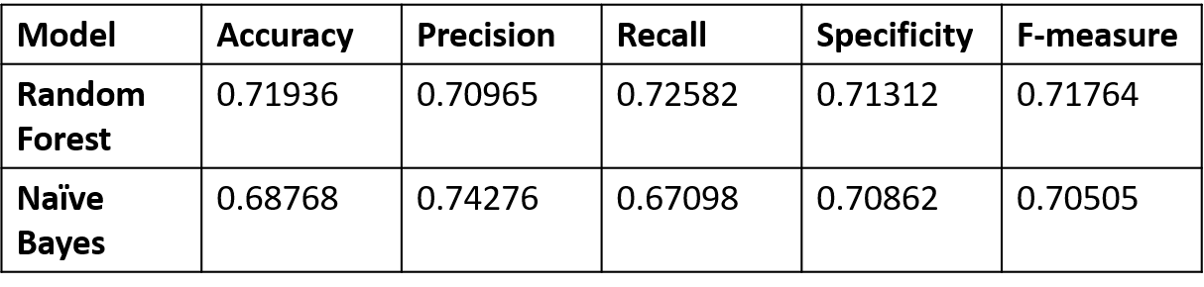

|  |  |  |  |  |
| --- | --- | --- | --- | --- |
|  | **Random Forest** | | **Naïve bayes** | |
| **Average time /seconds** | **Average accuracy** | **Average Time /seconds** | **Average accuracy** |
| **Bayesian optimization** | 1326.5 | 0.7178 | 473 | 0.68768 |
| **Grid search** | 913.1 | 0.7092 | 1320.6 | 0.68768 |
| **Random search** | 1092.5 | 0.71384 | 318.3 | 0.68768 |
| **AdaboostM1** | 2874.1 | 0.69677 | - | - |

1. Implementation details including a brief description of main implementation choices